**MYSQL PROJECT - LIBRARY MANAGEMENT SYSTEM**

**Topic : Library Management System  
Created by: NABIL MOHAMMED SHAJAHAN**

I am going to build a project named Library Management System. It keeps track of all information about books in the library, their cost, status and total number of books available in the library.

Create a database named library and following TABLES in the database:

1. Branch 2. Employee 3. Books 4. Customer 5. IssueStatus 6. ReturnStatus

CREATE DATABASE library;

USE library;

Attributes for the tables:

1. Branch Branch_no - Set as PRIMARY KEY Manager_Id Branch_address Contact_no

2. Employee Emp_Id – Set as PRIMARY KEY Emp_name Position Salary Branch_no - Set as FOREIGN KEY and it refer Branch_no in Branch table

3. Books ISBN - Set as PRIMARY KEY Book_title Category Rental_Price Status [Give yes if book available and no if book not available] Author Publisher

4. Customer Customer_Id - Set as PRIMARY KEY Customer_name Customer_address Reg_date

5. IssueStatus Issue_Id - Set as PRIMARY KEY Issued_cust – Set as FOREIGN KEY and it refer customer_id in CUSTOMER table Issued_book_name Issue_date Isbn_book –

Set as FOREIGN KEY and it should refer isbn in BOOKS table

6. ReturnStatus Return_Id - Set as PRIMARY KEY Return_cust Return_book_name Return_date Isbn_book2 - Set as FOREIGN KEY and it should refer isbn in BOOKS table

Display all the tables

CREATE TABLE Branch (

Branch_no INT PRIMARY KEY,

Manager_Id INT,

Branch_address VARCHAR(255),

Contact_no VARCHAR(15)

);

INSERT INTO Branch VALUES

*(1, 101, '123 Main St', '555-1234'),*

*(2, 102, '456 Elm St', '555-5678'),*

*(3, 103, '789 Oak St', '555-7890'),*

*(4, 104, '321 Birch St', '555-4321'),*

*(5, 105, '654 Pine St', '555-6543'),*

*(6, 106, '987 Cedar St', '555-9876'),*

*(7, 107, '123 Maple St', '555-1235'),*

*(8, 108, '456 Ash St', '555-5679'),*

*(9, 109, '789 Willow St', '555-7891'),*

*(10, 110, '321 Poplar St', '555-4322'),*

*(11, 111, '654 Fir St', '555-6544'),*

*(12, 112, '987 Spruce St', '555-9877'),*

*(13, 113, '123 Cypress St', '555-1236'),*

*(14, 114, '456 Redwood St', '555-5680'),*

*(15, 115, '789 Sequoia St', '555-7892'),*

*(16, 116, '321 Dogwood St', '555-4323'),*

*(17, 117, '654 Elmwood St', '555-6545'),*

*(18, 118, '987 Magnolia St', '555-9878'),*

*(19, 119, '123 Hawthorn St', '555-1237'),*

*(20, 120, '456 Chestnut St', '555-5681'),*

*(21, 121, '789 Sycamore St', '555-7893'),*

*(22, 122, '321 Juniper St', '555-4324'),*

*(23, 123, '654 Laurel St', '555-6546'),*

*(24, 124, '987 Aspen St', '555-9879'),*

*(25, 125, '123 Willow Ave', '555-9988');*

CREATE TABLE Employee (

Emp_Id INT PRIMARY KEY,

Emp_name VARCHAR(100),

Position VARCHAR(50),

Salary DECIMAL(10, 2),

Branch_no INT,

FOREIGN KEY (Branch_no) REFERENCES Branch(Branch_no)

);

INSERT INTO Employee VALUES

*(1, 'John Doe', 'Manager', 60000, 4),*

*(2, 'Jane Smith', 'Assistant Manager', 45000, 2),*

*(3, 'David Brown', 'Librarian', 40000, 1),*

*(4, 'Mary Johnson', 'Assistant Librarian', 35000, 4),*

*(5, 'Emily Davis', 'Library Assistant', 30000, 3),*

*(6, 'Michael Wilson', 'Library Clerk', 28000, 5),*

*(7, 'James Taylor', 'IT Support', 42000, 1),*

*(8, 'Sarah Lee', 'Library Assistant', 31000, 3),*

*(9, 'Robert Miller', 'Library Clerk', 29000, 6),*

*(10, 'Laura Moore', 'Manager', 62000, 2),*

*(11, 'Patricia White', 'Librarian', 43000, 1),*

*(12, 'Daniel Harris', 'Assistant Librarian', 34000, 2),*

*(13, 'Christopher Martin', 'Library Assistant', 29500, 4),*

*(14, 'Angela Jackson', 'Library Clerk', 28500, 6),*

*(15, 'Lisa Thompson', 'Assistant Manager', 45500, 3),*

*(16, 'Anthony Martinez', 'IT Support', 41500, 5),*

*(17, 'Betty Clark', 'Manager', 61000, 1),*

*(18, 'Charles Lewis', 'Library Assistant', 30000, 2),*

*(19, 'Karen Walker', 'Librarian', 42000, 6),*

*(20, 'Joseph Allen', 'Library Clerk', 29000, 2),*

*(21, 'Susan Young', 'Assistant Librarian', 35000, 4),*

*(22, 'Linda King', 'Library Clerk', 28000, 5),*

*(23, 'Brian Wright', 'Manager', 60000, 6),*

*(24, 'Nancy Hill', 'Librarian', 41000, 2),*

*(25, 'Lucas Brown', 'Library Assistant', 35000, 1);*

CREATE TABLE Books (

ISBN VARCHAR(20) PRIMARY KEY,

Book_title VARCHAR(255),

Category VARCHAR(100),

Rental_Price DECIMAL(5, 2),

Status VARCHAR(3),

Author VARCHAR(100),

Publisher VARCHAR(100)

);

INSERT INTO Books VALUES

*('978-3-16-148410-0', 'Introduction to MySQL', 'Database', 15.99, 'Yes', 'Author A', 'Publisher A'),*

*('978-1-56619-909-4', 'Learning SQL', 'Database', 17.99, 'No', 'Author B', 'Publisher B'),*

*('978-0-596-52068-7', 'Mastering Database Design', 'Database', 18.99, 'Yes', 'Author C', 'Publisher C'),*

*('978-1-4028-9462-6', 'Advanced SQL Queries', 'Database', 25.99, 'Yes', 'Author D', 'Publisher D'),*

*('978-0-321-48681-3', 'Database Systems', 'Computer Science', 35.99, 'No', 'Author E', 'Publisher E'),*

*('978-1-4919-1889-0', 'Python for Data Science', 'Programming', 45.99, 'Yes', 'Author F', 'Publisher F'),*

*('978-1-4493-8970-4', 'Learning Python', 'Programming', 50.99, 'Yes', 'Author G', 'Publisher G'),*

*('978-0-201-63451-2', 'Algorithms', 'Computer Science', 30.99, 'No', 'Author H', 'Publisher H'),*

*('978-1-118-43467-9', 'Artificial Intelligence', 'Computer Science', 55.99, 'Yes', 'Author I', 'Publisher I'),*

*('978-0-07-178368-7', 'Introduction to Networking', 'Computer Networks', 22.99, 'Yes', 'Author J', 'Publisher J'),*

*('978-0-387-95284-6', 'Cybersecurity Fundamentals', 'Computer Networks', 32.99, 'Yes', 'Author K', 'Publisher K'),*

*('978-0-521-86538-6', 'Operating Systems', 'Computer Science', 40.99, 'No', 'Author L', 'Publisher L'),*

*('978-1-59327-599-0', 'The Linux Command Line', 'Operating Systems', 39.99, 'Yes', 'Author M', 'Publisher M'),*

*('978-1-4919-4547-6', 'JavaScript: The Good Parts', 'Programming', 23.99, 'Yes', 'Author N', 'Publisher N'),*

*('978-0-596-51979-6', 'Designing Web APIs', 'Web Development', 29.99, 'No', 'Author O', 'Publisher O'),*

*('978-1-59327-290-6', 'Python Crash Course', 'Programming', 27.99, 'Yes', 'Author P', 'Publisher P'),*

*('978-0-12-802902-9', 'Computer Networks', 'Computer Networks', 49.99, 'No', 'Author Q', 'Publisher Q'),*

*('978-1-4919-0370-4', 'High Performance MySQL', 'Database', 55.99, 'Yes', 'Author R', 'Publisher R'),*

*('978-0-262-03384-8', 'Introduction to Algorithms', 'Computer Science', 65.99, 'No', 'Author S', 'Publisher S'),*

*('978-1-59327-891-5', 'Shell Scripting', 'Operating Systems', 45.99, 'Yes', 'Author T', 'Publisher T'),*

*('978-1-59327-424-5', 'Web Development with Node.js', 'Web Development', 33.99, 'No', 'Author U', 'Publisher U'),*

*('978-0-13-438998-2', 'The Pragmatic Programmer', 'Programming', 39.99, 'Yes', 'Author V', 'Publisher V'),*

*('978-0-321-48681-2', 'Operating Systems: Internals and Design Principles', 'Computer Science', 41.99, 'Yes', 'Author W', 'Publisher W'),*

*('978-0-13-477102-3', 'Database Management Systems', 'Database', 49.99, 'Yes', 'Author X', 'Publisher X'),*

*('978-1-118-83835-9', 'Computer Science: An Overview', 'Computer Science', 60.99, 'Yes', 'Author Y', 'Publisher Y');*

CREATE TABLE Customer (

Customer_Id INT PRIMARY KEY,

Customer_name VARCHAR(100),

Customer_address VARCHAR(255),

Reg_date DATE

);

INSERT INTO Customer VALUES

*(1, 'Alice Johnson', '789 Maple St', '2021-09-01'),*

*(2, 'Bob Williams', '456 Oak St', '2022-08-02'),*

*(3, 'Carol Taylor', '123 Pine St', '2023-07-03'),*

*(4, 'Daniel Anderson', '987 Cedar St', '2024-06-04'),*

*(5, 'Emily Scott', '654 Birch St', '2021-06-05'),*

*(6, 'Frank White', '321 Elm St', '2022-06-06'),*

*(7, 'Grace Lee', '123 Maple St', '2023-05-07'),*

*(8, 'Harry Walker', '456 Oak St', '2024-04-08'),*

*(9, 'Irene Miller', '789 Pine St', '2021-03-09'),*

*(10, 'James Clark', '987 Cedar St', '2022-03-10'),*

*(11, 'Karen Wright', '654 Birch St', '2023-02-11'),*

*(12, 'Larry Young', '321 Elm St', '2024-02-12'),*

*(13, 'Maria Thompson', '123 Maple St', '2021-01-13'),*

*(14, 'Nancy Jackson', '456 Oak St', '2022-01-01'),*

*(15, 'Oliver Harris', '789 Pine St', '2023-12-15'),*

*(16, 'Patricia King', '987 Cedar St', '2024-12-16'),*

*(17, 'Quincy Lewis', '654 Birch St', '2021-11-17'),*

*(18, 'Rebecca Martin', '321 Elm St', '2022-11-18'),*

*(19, 'Samuel Allen', '123 Maple St', '2023-11-19'),*

*(20, 'Tina Nelson', '456 Oak St', '2024-10-20'),*

*(21, 'Ursula Baker', '789 Pine St', '2021-10-21'),*

*(22, 'Victor Perez', '987 Cedar St', '2022-10-22'),*

*(23, 'Wendy Rivera', '654 Birch St', '2022-09-23'),*

*(24, 'Xavier Brooks', '321 Elm St', '2023-07-24'),*

*(25, 'Yvonne Bennett', '123 Maple St', '2021-07-25');*

CREATE TABLE IssueStatus (

Issue_Id INT PRIMARY KEY,

Issued_cust INT,

Issued_book_name VARCHAR(255),

Issue_date DATE,

Isbn_book VARCHAR(20),

FOREIGN KEY (Issued_cust) REFERENCES Customer(Customer_Id),

FOREIGN KEY (Isbn_book) REFERENCES Books(ISBN)

);

INSERT INTO IssueStatus VALUES

*(1, 1, 'Introduction to MySQL', '2021-01-01', '978-3-16-148410-0'),*

*(2, 2, 'Learning SQL', '2022-01-02', '978-1-56619-909-4'),*

*(3, 3, 'Mastering Database Design', '2023-02-03', '978-0-596-52068-7'),*

*(4, 4, 'Advanced SQL Queries', '2024-02-04', '978-1-4028-9462-6'),*

*(5, 5, 'Database Systems', '2021-03-05', '978-0-321-48681-3'),*

*(6, 6, 'Python for Data Science', '2022-03-06', '978-1-4919-1889-0'),*

*(7, 7, 'Learning Python', '2023-04-07', '978-1-4493-8970-4'),*

*(8, 8, 'Algorithms', '2024-04-08', '978-0-201-63451-2'),*

*(9, 9, 'Artificial Intelligence', '2021-05-09', '978-1-118-43467-9'),*

*(10, 10, 'Introduction to Networking', '2022-05-10', '978-0-07-178368-7'),*

*(11, 11, 'Cybersecurity Fundamentals', '2023-06-11', '978-0-387-95284-6'),*

*(12, 12, 'Operating Systems', '2024-06-12', '978-0-521-86538-6'),*

*(13, 13, 'The Linux Command Line', '2021-07-13', '978-1-59327-599-0'),*

*(14, 14, 'JavaScript: The Good Parts', '2022-07-14', '978-1-4919-4547-6'),*

*(15, 15, 'Designing Web APIs', '2023-08-15', '978-0-596-51979-6'),*

*(16, 16, 'Python Crash Course', '2024-08-16', '978-1-59327-290-6'),*

*(17, 17, 'Computer Networks', '2021-09-17', '978-0-12-802902-9'),*

*(18, 18, 'High Performance MySQL', '2022-09-18', '978-1-4919-0370-4'),*

*(19, 19, 'Introduction to Algorithms', '2023-10-19', '978-0-262-03384-8'),*

*(20, 20, 'Shell Scripting', '2024-10-20', '978-1-59327-891-5'),*

*(21, 21, 'Web Development with Node.js', '2021-11-21', '978-1-59327-424-5'),*

*(22, 22, 'The Pragmatic Programmer', '2022-11-22', '978-0-13-438998-2'),*

*(23, 23, 'Operating Systems: Internals and Design Principles', '2022-12-23', '978-0-321-48681-2'),*

*(24, 24, 'Database Management Systems', '2023-12-24', '978-0-13-477102-3'),*

*(25, 25, 'Computer Science: An Overview', '2024-12-25', '978-1-118-83835-9');*

CREATE TABLE ReturnStatus (

Return_Id INT PRIMARY KEY,

Return_cust INT,

Return_book_name VARCHAR(255),

Return_date DATE,

Isbn_book2 VARCHAR(20),

FOREIGN KEY (Return_cust) REFERENCES Customer(Customer_Id),

FOREIGN KEY (Isbn_book2) REFERENCES Books(ISBN)

);

INSERT INTO ReturnStatus VALUES

*(1, 1, 'Introduction to MySQL', '2021-01-10', '978-3-16-148410-0'),*

*(2, 2, 'Learning SQL', '2022-01-12', '978-1-56619-909-4'),*

*(3, 3, 'Mastering Database Design', '2023-01-14', '978-0-596-52068-7'),*

*(4, 4, 'Advanced SQL Queries', '2024-02-16', '978-1-4028-9462-6'),*

*(5, 5, 'Database Systems', '2021-02-18', '978-0-321-48681-3'),*

*(6, 6, 'Python for Data Science', '2022-03-20', '978-1-4919-1889-0'),*

*(7, 7, 'Learning Python', '2023-03-22', '978-1-4493-8970-4'),*

*(8, 8, 'Algorithms', '2024-04-24', '978-0-201-63451-2'),*

*(9, 9, 'Artificial Intelligence', '2021-04-26', '978-1-118-43467-9'),*

*(10, 10, 'Introduction to Networking', '2022-05-28', '978-0-07-178368-7'),*

*(11, 11, 'Cybersecurity Fundamentals', '2023-05-30', '978-0-387-95284-6'),*

*(12, 12, 'Operating Systems', '2024-06-01', '978-0-521-86538-6'),*

*(13, 13, 'The Linux Command Line', '2021-06-02', '978-1-59327-599-0'),*

*(14, 14, 'JavaScript: The Good Parts', '2022-07-03', '978-1-4919-4547-6'),*

*(15, 15, 'Designing Web APIs', '2023-07-04', '978-0-596-51979-6'),*

*(16, 16, 'Python Crash Course', '2024-08-05', '978-1-59327-290-6'),*

*(17, 17, 'Computer Networks', '2021-08-06', '978-0-12-802902-9'),*

*(18, 18, 'High Performance MySQL', '2022-09-07', '978-1-4919-0370-4'),*

*(19, 19, 'Introduction to Algorithms', '2023-09-08', '978-0-262-03384-8'),*

*(20, 20, 'Shell Scripting', '2024-10-09', '978-1-59327-891-5'),*

*(21, 21, 'Web Development with Node.js', '2021-10-10', '978-1-59327-424-5'),*

*(22, 22, 'The Pragmatic Programmer', '2021-11-11', '978-0-13-438998-2'),*

*(23, 23, 'Operating Systems: Internals and Design Principles', '2022-11-12', '978-0-321-48681-2'),*

*(24, 24, 'Database Management Systems', '2023-12-13', '978-0-13-477102-3'),*

*(25, 25, 'Computer Science: An Overview', '2023-12-14', '978-1-118-83835-9');*

SELECT * FROM Branch;

SELECT * FROM Employee;

SELECT * FROM Books;

SELECT * FROM Customer;

SELECT * FROM IssueStatus;

SELECT * FROM ReturnStatus;

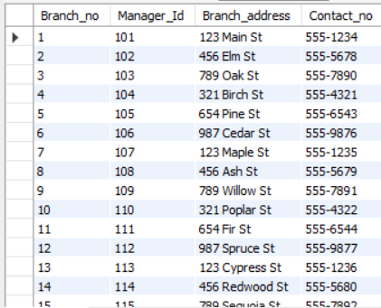 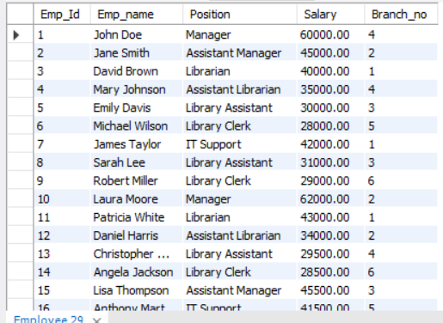

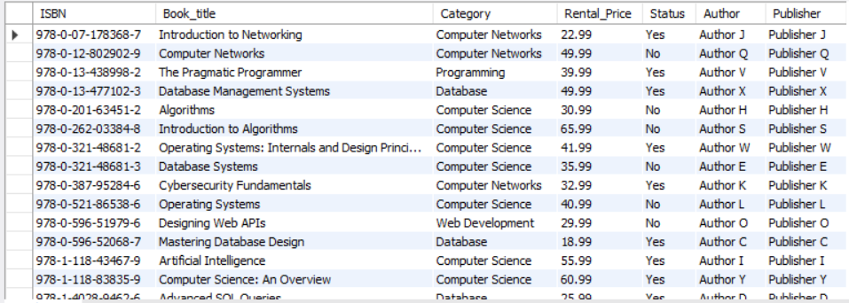

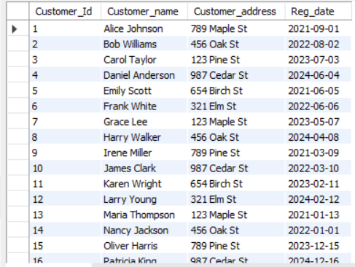 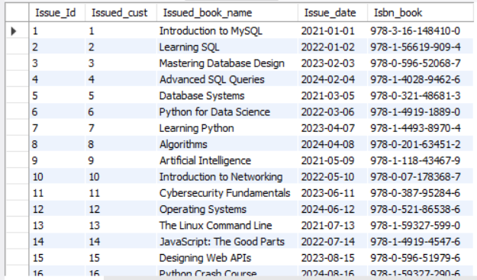

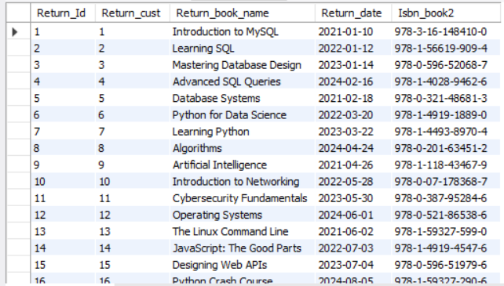

1. Retrieve the book title, category, and rental price of all available books.

SELECT Book_title, Category, Rental_Price

FROM Books WHERE Status = 'Yes';

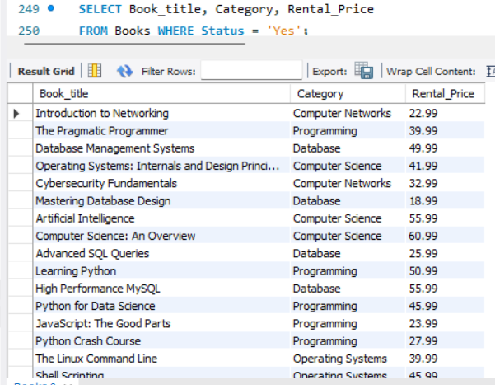

2. List the employee names and their respective salaries in descending order of salary.

SELECT Emp_Id, Emp_name,

Salary FROM Employee

ORDER BY Salary DESC;

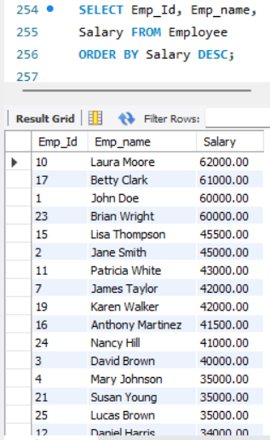

3. Retrieve the book titles and the corresponding customers who have issued those books.

SELECT IssueStatus.Issued_cust,

IssueStatus.Issued_book_name,

Customer.Customer_name

FROM IssueStatus LEFT JOIN Customer

ON IssueStatus.Issued_cust = Customer.Customer_Id;

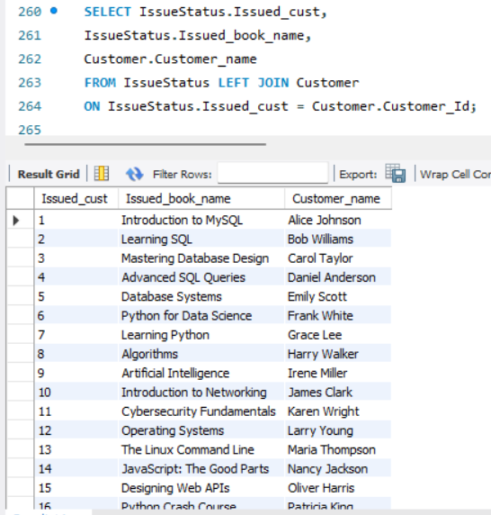

4. Display the total count of books in each category.

SELECT Category,

COUNT(*) AS NoOfBooks

FROM Books GROUP BY

Category;

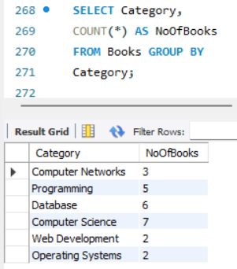

5. Retrieve the employee names and their positions for the employees whose salaries are above Rs.50,000.

SELECT Emp_name,

Position, Salary

FROM Employee WHERE

Salary > 50000;

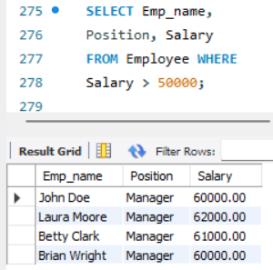

6. List the customer names who registered before 2022-01-01 and their issued books.

SELECT Customer.Reg_date, Customer.Customer_name,

IssueStatus.Issued_book_name FROM Customer

LEFT JOIN IssueStatus ON

Customer.Customer_Id = IssueStatus.Issued_cust

WHERE Customer.Reg_date < '2022-01-01';

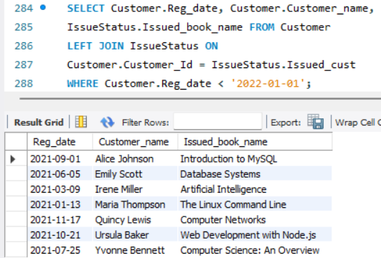

7. Display the branch numbers and the total count of employees in each branch.

SELECT Branch_no,

COUNT(*) AS NoOfEmployees

FROM Employee

GROUP BY Branch_no;

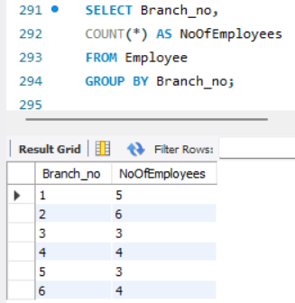

8. Display the names of customers who have issued books in the month of June 2023.

SELECT Customer.Customer_name,

IssueStatus.Issued_book_name,

IssueStatus.Issue_date

FROM Customer LEFT JOIN IssueStatus

ON Customer.Customer_Id = IssueStatus.Issued_cust

WHERE IssueStatus.Issue_date

BETWEEN '2023-06-01' AND '2023-06-30';

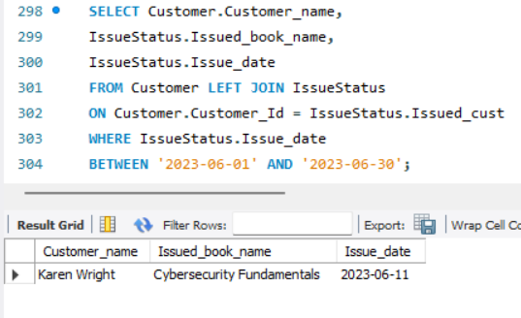

9. Retrieve book titles from books table containing database.

SELECT ISBN, Book_title, Author

FROM Books WHERE Category = 'Database'

ORDER BY ISBN;

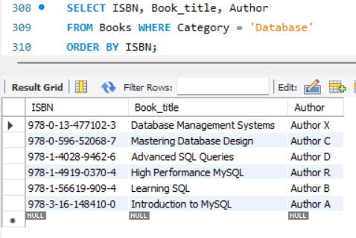

10.Retrieve the branch numbers along with the count of employees for branches having more than 4 employees.

SELECT Branch_no,

COUNT(*) AS NoOfEmployees

FROM Employee

GROUP BY Branch_no

HAVING COUNT(*) > 4;

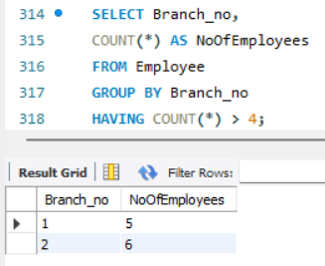

11. Retrieve the names of employees who manage branches and their respective branch addresses.

SELECT Employee.Emp_name,

Employee.Branch_no,

Branch.Branch_address

FROM Employee LEFT JOIN Branch ON

Employee.Branch_no = Branch.Branch_no

WHERE Employee.Position = 'Manager'

ORDER BY Branch_no;

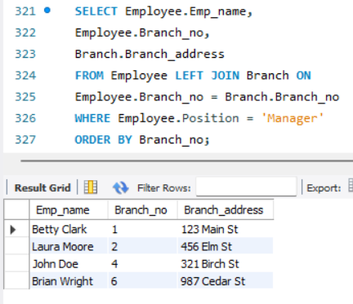

12. Display the names of customers who have issued books with a rental price higher than Rs. 25.

SELECT Customer.Customer_name, Books.Book_title,

Books.Rental_Price

FROM Customer INNER JOIN IssueStatus

ON Customer.Customer_Id = IssueStatus.Issued_cust

INNER JOIN Books ON

IssueStatus.Isbn_book = Books.ISBN

WHERE Books.Rental_Price > 25;

